**HQL: Logs & Errors Analysis**

1. Creating table for the log data.



1. Loading data into the table.

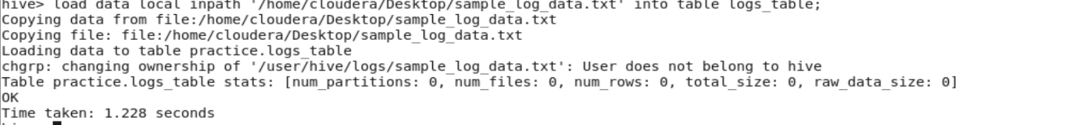

3.Basic log queries

a.View all logs

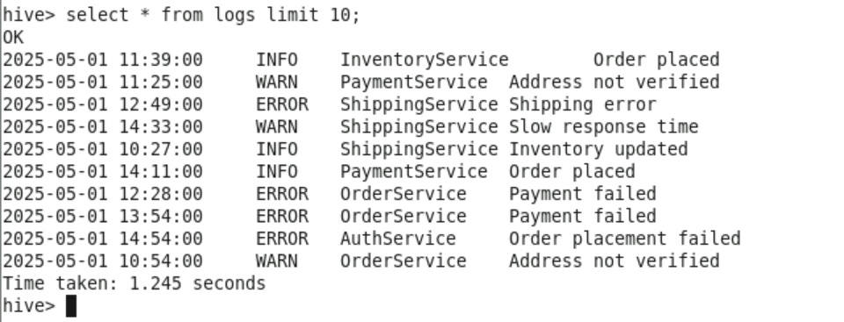

b.Count total logs

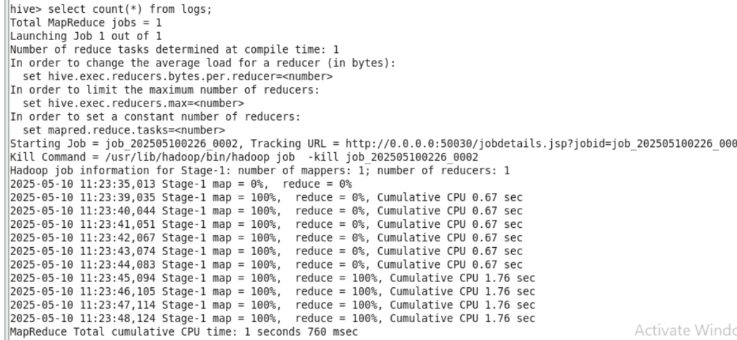

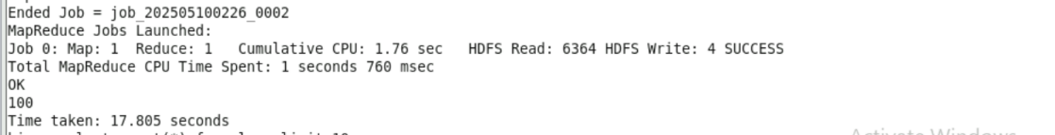

c. Count logs by Log Level

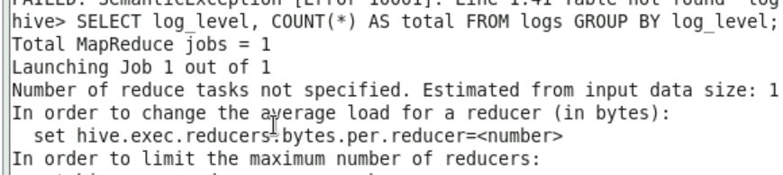

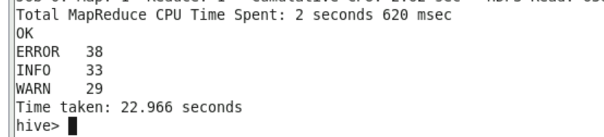

d. Count ERROR logs per service

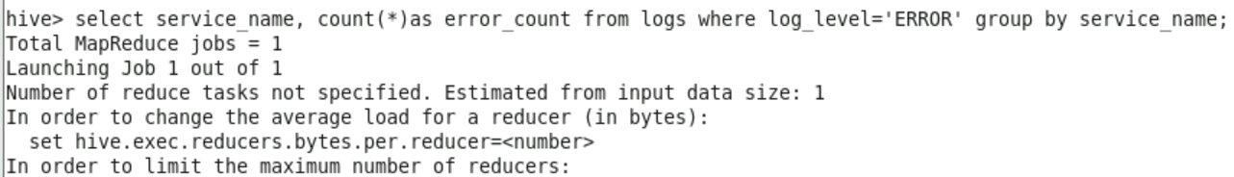

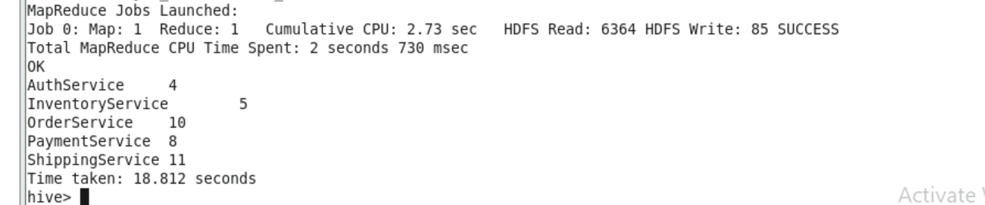

4. Filter logs by date

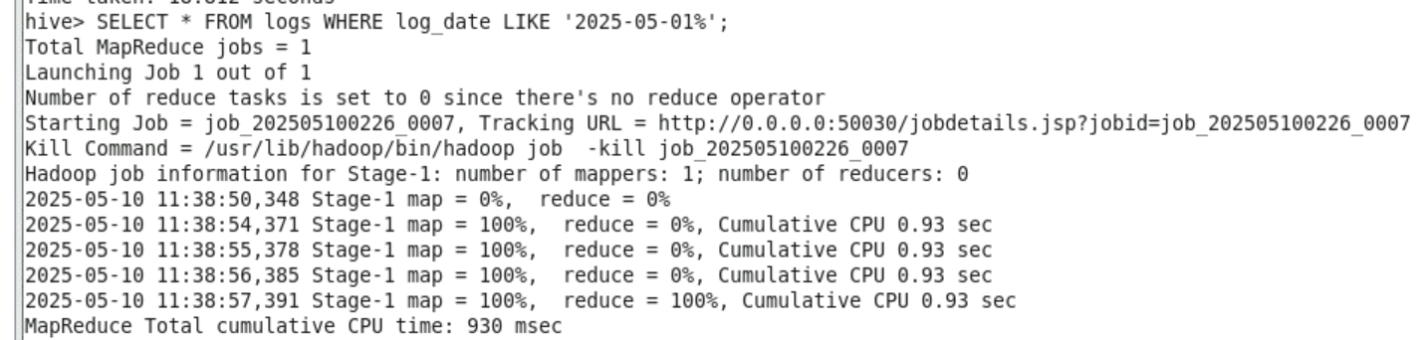

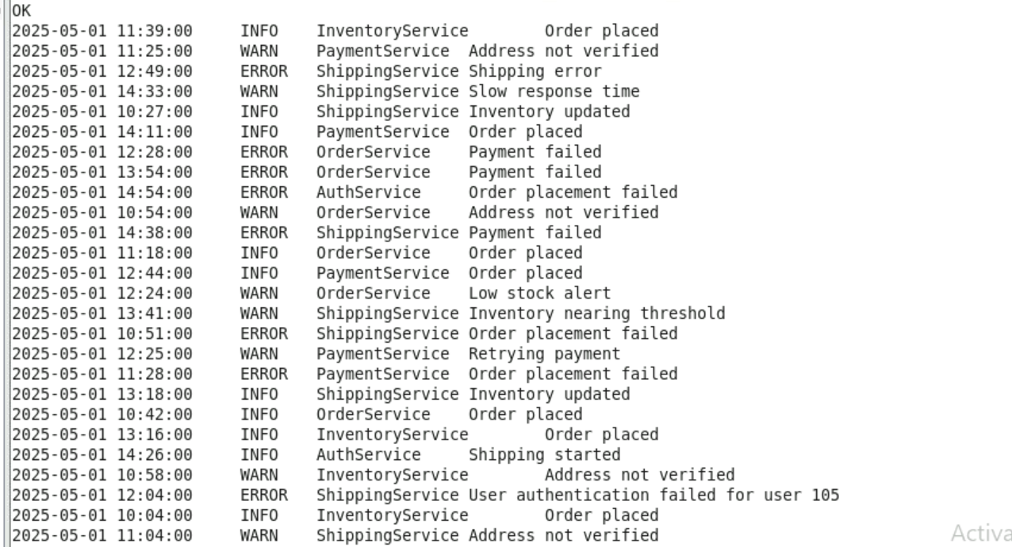

5. Create partitioned table by date

